MailingAddress

Dear FullName,

Receipt Sunday, February 13, 2011

On behalf of Rabbi Weinberger and Congregation Shomrei Torah of Passaic Clifton, I would like to express my sincere gratitude and appreciation for your generous contributions to our Shul.

Below is your Year annual contributions summary. If you have any questions, please email Billing@ShomreiTorah.us or contact Levi Krinsky at (973) 594 – 7972.

May your support of our Shul bring you ברכה and הצלחה in all of your endeavors.

Deductibility

Thank you.

Table

Sincerely,

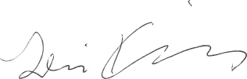

Levi Krinsky

Treasurer